Directions to help guide and examples from past Playbills shown below.
- Must be in png or jpeg format.
- Must be one of the following sizes:
  - Full Page Recommended dimensions: 2120 x 3176 (this should be a vertical layout)
  - Half Page Recommended dimensions: 2120 x 1548 (this should be a horizontal layout)
  - Qtr Page Recommended dimensions: 1020 x 1548 (this should be a vertical layout)

If you do not know how to make an ad, you can use different sites like:
https://www.photopea.com/
adobe photo shop
https://www.canva.com/features/add-text-to-photo/
https://picsart.com/create
These are pretty easy to use , but please feel free to reach out for help.
Next -
Once you create a Shout Out Photo ad, please make sure it is the right layout and size for the shout out you are purchasing.
The playbill is very picky when I upload and start to lay out.
If you are unsure, you can use sites to resize your images like:
https://resizeimage.net/
https://online-image-resizer.com/
https://imageresizer.com/
Save and send to lttappres@gmail.com.
I will let you know if there are any issues.
If I must fix something, I will always send back to you for approval.
Thanks.
Monica
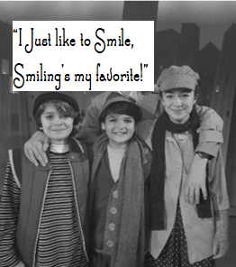
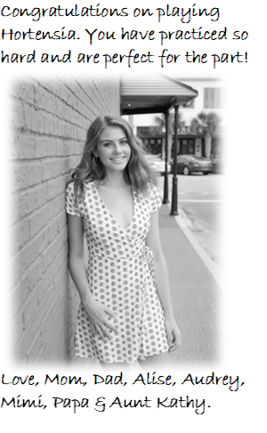
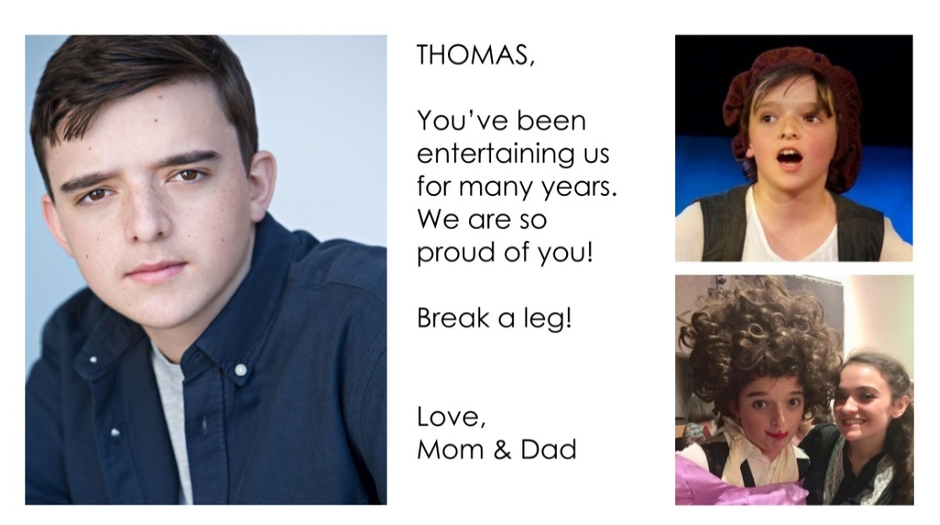
SHOUT OUT EXAMPLES

