Directions to help guide and examples of Shout Outs from past Playbills shown below.
- Must be in jpg format.
- Must be one of the following sizes:
  - Full Page Recommended dimensions: 2120 x 3176 (this should be a vertical layout)
  - Half Page Recommended dimensions: 2120 x 1548 (this should be a horizontal layout)
  - Qtr Page Recommended dimensions: 1020 x 1548 (this should be a vertical layout)
If you do not know how to make an ad, you can use different sites like:
https://www.photopea.com/
adobe photo shop
Preferred: https://www.canva.com/features/add-text-to-photo/
https://picsart.com/create
These are pretty easy to use, but please feel free to reach out for help.
Next -
Once you create a Shout Out Photo ad, please make sure it is in black and white, the right layout and size for the shout out you are purchasing.
The playbill is very picky when I upload and start to lay out.
If you are unsure, you can use sites to resize your images like:
https://resizeimage.net/
https://online-image-resizer.com/
https://imageresizer.com/
https://blackandwhite.imageonline.co/
Save and send to lttapvp1@gmail.com.
I will let you know if there are any issues.
If I must fix something, I will always send back to you for approval.
Thanks!
Kim
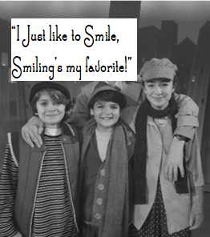
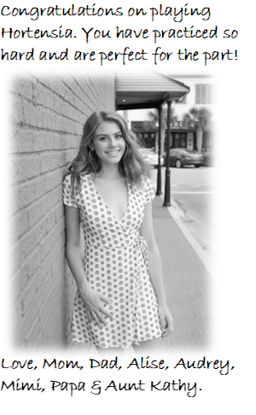
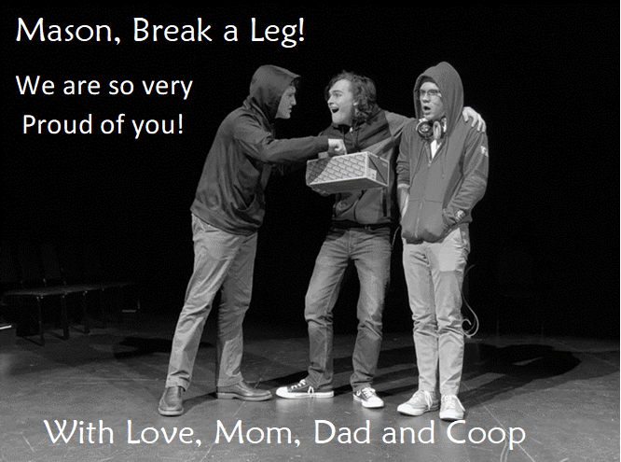
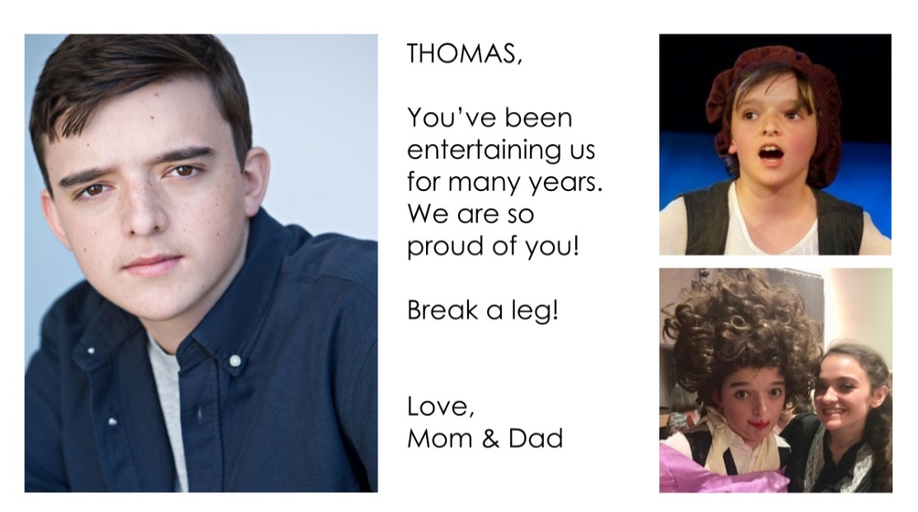
SHOUT OUT EXAMPLES

